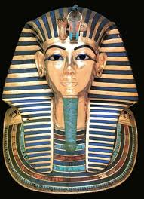

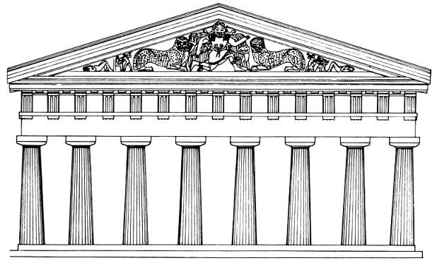

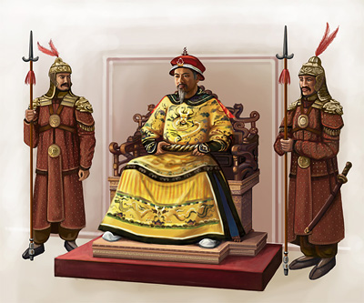

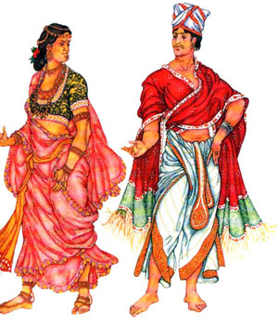

**People and places: Ancient Times**

(Student 1)

1

**Watch a short video film about the first civilizations. Say whether the sentences are true or false.**

1. Such activities as farming and the domestication of animals were one of the reasons for the foundation of the first civilizations _________

2. Irrigation produced enough food for people to settle on villages by 500 B.C. _________

3. Many useful tools made of stone were invented in different times. _________

4. The civilization of this era left remarkable treasures. _________

5. The Empires of Greece, Rome and Egypt built the foundation of western Civilization in various aspects. _________

2

**Work in pairs. Fill in the missing part of the table by asking and answering questions of your partner**

|  |  |  |  |
| --- | --- | --- | --- |
|  | **Mesopotamia** | **Ancient China** | **Ancient India** |
| **Time** | From 5000 B.C. |  | From 4000 B.C |
| **Geography** |  | A large section of central and eastern Asia, Yellow River (Huang He), Chang Jiang (Long River), vast variety of different landscapes | Subcontinent, Indian Ocean in the southern part, The Himalayan Mountains in the northern part |
| **Climate** | Hot summers, relatively cold winters, dry desert |  | Long dry season from October to May, heavy rains, monsoon |
| **Occupation** | Farming, agriculture, trade | Social classes, rice growing, tea growing, sericulture, trade |  |
| **Religion** |  | Ancestor worship,  Pantheism, Confucianism, Daoism, Buddhism | Pantheism, Hinduism, Buddhism, Muslim |

